You have made it into the lair! Congratulations!

You notice Data V.I.K.I.N.G Vi Banks’ laptop sitting on the countertop, you know that this has the secret evil plan on it, so you need to access the file and send it back to Major X, then destroy it.

The laptop has a security lock on it though. Use the hints on the post-it-note and the graphing tool to find the password and unlock the laptop.

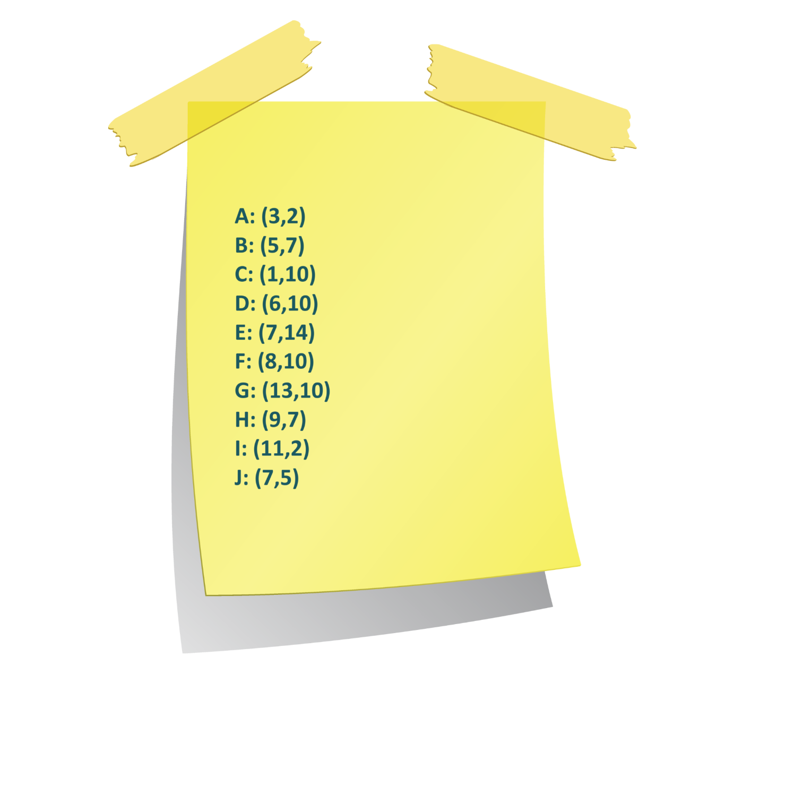

These coordinates on the post-it-note represent points in Vi’s favourite shape which is also the password. What is the shape?

Hint: A quote from Vi: "Nothing beats kicking back after dusk, eyes glued to those twinkling specks painting the night”

Answer: star